HKU Alumni Association Golf Day/ Challenge Cup 2007
The Old Course of the Hong Kong Golf Club, Fanling
Wednesday, 18th April 2007

The Challenge Cup day is the competition for the Challenge Cup donated by our Honorary Vice-President, Dr. George Choa and the winner awarded the Challenge Cup (Trophy) with his/her name engraved on the Challenge Cup was entitled to keep it until the next annual event.

This year, the competition was held on 18 April 2007 in the Old Course of the Hong Kong Golf Club in Fanling. There are 47 participants joined the event. The Stableford Scoring System was applied and full handicap allowance was used for the tournament, with a handicap index cap of 22. The player with the highest Stableford points over 18 holes was declared the champion of Challenge Cup. Congratulations to the following winners:

Gross Champion:  Mr Cheung Yuk Tong (85)  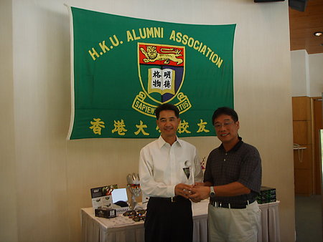 | Net Champion:  Mr Wan Kwong Yiu (38 points)  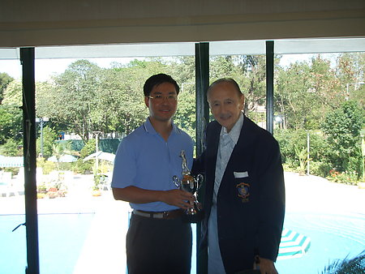
1st runner up:  Ms Lai Ha Lee (36 points)  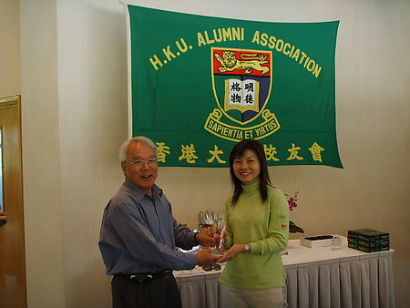 | 2nd runner up:  Ms Carol Tsang (35 points)  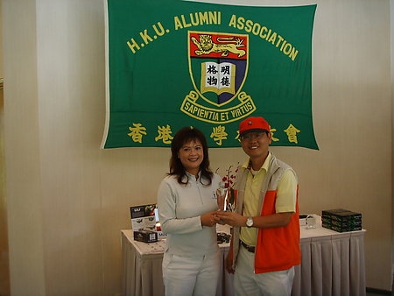

Longest Drive: Mr Gabriel Yu

Closet to pin: Mr Henry Tang

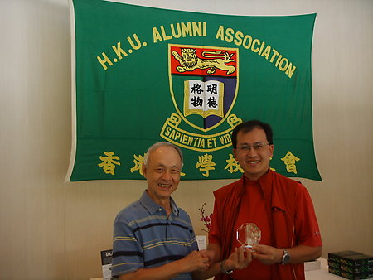
The Golf Interest Group of HKUAA would like to thank our Sponsors, Falcon Insurance Company (Hong Kong) Limited and JNC Datum Tech. International Ltd for their generous of souvenirs and gift items. Last but not least, we must thank all the participants to the event. With your support, we will continue to organize more events in the near future for HKUAA members.

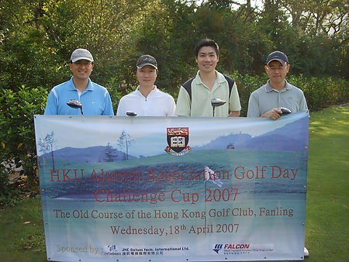 | 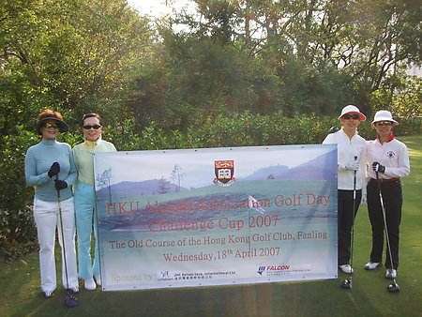
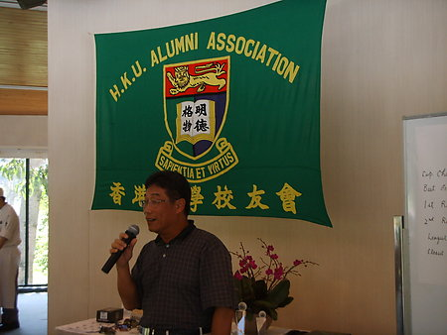 | 